**Use Case “Pay Order”**

1. **Use case code**

UC002

1. **Brief Description**

This use case describes the interactions between the AIMS software with the customer and Interbank when the customer desires to pay order. The precondition of this use case is that the AIMS software has calculated the total amount of money which the customer has to pay. On the other hand, there is no need specification of output data nor the postcondition. An incomplete example for the basic flow of events is listed as follows.

1. **Actors**
   1. **Name of Actor 1: Customer**
   2. **Name of Actor 2: Interbank**
2. **Preconditions**
3. **Basic Flow of Events**
4. The AIMS software displays the payment screen
5. The customer enters card info and confirm to pay order
6. The AIMS software check if the card info is in correct format
7. The AIMS software asks the Interbank to pay order
8. The Interbank processes the transaction
9. The AIMS software saves the payment transaction.
10. **Alternative flows**

Table N-Alternative flows of events for UC Place order

|  |  |  |  |  |
| --- | --- | --- | --- | --- |
| **No** | **Location** | **Condition** | **Action** | **Resume location** |
|  | At Step 4 | If the card info has wrong  format | * The AIMS software notifies that the card info has wrong format | At Step 1 |
|  | At Step 5 | If the card info is invalid | * The AIMS software notifies that the balance is not enough | At Step 1 |
|  | At  Step  5Error!  Reference  source not  found. | If the balance is not enough | * The AIMS software notifies that   the balance is not enough | At Step 1 |

1. **Activity diagrams**

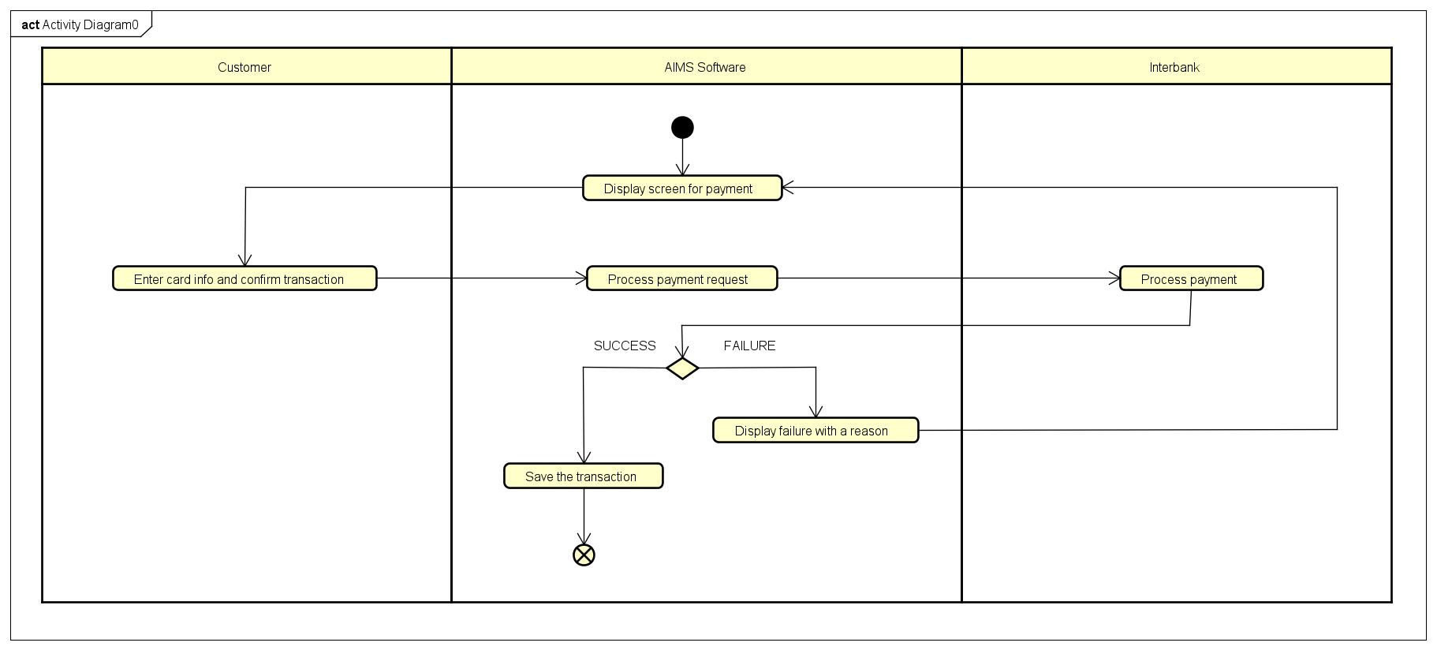

1. **Input data**

Table A-Input data of payment form

|  |  |  |  |  |  |
| --- | --- | --- | --- | --- | --- |
| **No** | **Data fields** | **Description** | **Mandatory** | **Valid condition** | **Example** |
|  | Card holder name |  | Yes |  | Dao Duc Manh |
|  | Card number |  | Yes |  | 234 5678 9123 4567 |
|  | Expiration date |  | Yes | Consist of month and  last 2 digits of year only | 01/23 |
|  | Security code |  | Yes |  | 123 |

1. **Output data**

Table B-Output data of …

|  |  |  |  |  |
| --- | --- | --- | --- | --- |
| **No** | **Data fields** | **Description** | **Display format** | **Example** |
|  |  |  |  |  |

1. **Postconditions: None**